Data Definition Language (DDL)
The SQL DDL category provides commands for defining, deleting and modifying tables in a database. Use the following commands in this category.
CREATE Command
Purpose: To create the database or tables inside the database
Syntax to create a table with three columns:
CREATE TABLE table_name (column_name1 datatype(size), column_name2 datatype(size), column_name3 datatype(size));
DROP Command
Purpose: To delete a database or a table inside the database.
Syntax to drop a table:
DROP TABLE table_name;

ALTER Command
Purpose: To change the structure of the tables in the database such as changing the name of a table, adding a primary key to a table, or adding or deleting a column in a table.
- Syntax to add a column into a table:

ALTER TABLE table_name ADD (column_name datatype(size));

2. Syntax to add a primary key to a table:
ALTER TABLE table_name ADD primary key (column_name);

TRUNCATE Command
Purpose: To remove all records from a table, which will empty the table but not delete the table itself.
Syntax to truncate a table:
TRUNCATE TABLE table_name;

COMMENT Command
Purpose: To add comments to explain or document SQL statements by using double dash (--) at the start of the line. Any text after the double dash will not be executed as part of the SQL statement. These comments are not there to build the database. They are only for your own use.
Syntax to COMMENT a line in SQL:
--Retrieve all data from a table
SELECT * FROM table_name;

Data Query Language (DQL)
The SQL DQL commands provide the ability to query and retrieve data from the database. Use the following command in this category.
SELECT Command
Purpose: To retrieve data from tables in the database.
Syntax to select data from a table:
SELECT * FROM table_name;

Data Manipulation Language (DML)
The SQL DML commands provide the ability to query, delete and update data in the database. Use the following commands in this category.
INSERT Command
Purpose: To add records of data into an existing table. Syntax to insert data into three columns in a table:

INSERT INTO table_name (column1, column2, column3) VALUES (value1, value2, value3);

UPDATE Command
Purpose: To modify or update data contained within a table in the database.
Syntax to update data in two columns:
UPDATE table_name SET column1 = value1, column2 = value2 WHERE condition;

DELETE Command
Purpose: To delete data from a table in the database.
Syntax to delete data:
DELETE FROM table_name WHERE condition;

Data Control Language (DCL)
You use DCL to deal with the rights and permissions of users of a database system. You can execute SQL commands to perform different types of operations such as create and drop tables. To do this, you need to have user rights set up. This is called user privileges. This category deals with advanced functions or operations in the database. Note that this category can have a generic description of the two main commands. Use the following commands in this category:
GRANT Command to provide the user of the database with the privileges required to allow users to access and manipulate the database.
REVOKE Command to remove permissions from any user.

Transaction Control Language (TCL)
The TCL commands are used to manage transactions in the database. These are used to manage the changes made to the data in a table by utilizing the DML commands. It also allows SQL statements to be grouped together into logical transactions. This category deals with advanced functions or operations in a database. Note that this category can have a generic description of the two main commands. Use the following commands in this category:
COMMIT Command to save all the work you have already done in the database.
ROLLBACK Command to restore a database to the last committed state.

SQL Datatype
- SQL Datatype is used to define the values that a column can contain.
- Every column is required to have a name and data type in the database table.

Datatype of SQL:
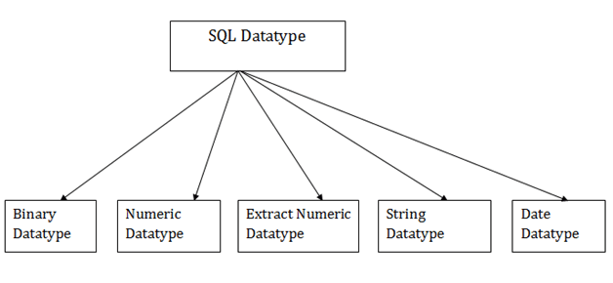

1. Binary Datatypes
There are Three types of binary Datatypes which are given below:
Data Type | Description
binary | It has a maximum length of 8000 bytes. It contains fixed-length binary data.
varbinary | It has a maximum length of 8000 bytes. It contains variable-length binary data.
image | It has a maximum length of 2,147,483,647 bytes. It contains variable-length binary data.

2. Approximate Numeric Datatype :
The subtypes are given below:
Data type | From | To | Description
float | -1.79E + 308 | 1.79E + 308 | It is used to specify a floating-point value e.g. 6.2, 2.9 etc.
real | -3.40e + 38 | 3.40E + 38 | It specifies a single precision floating point number

3. Exact Numeric Datatype
The subtypes are given below:
Data type | Description
int | It is used to specify an integer value.
smallint | It is used to specify small integer value.
bit | It has the number of bits to store.
decimal | It specifies a numeric value that can have a decimal number.
numeric | It is used to specify a numeric value.

4. Character String Datatype
The subtypes are given below:
Data type | Description
char | It has a maximum length of 8000 characters. It contains Fixed-length non-unicode characters.
varchar | It has a maximum length of 8000 characters. It contains variable-length non-unicode characters.
text | It has a maximum length of 2,147,483,647 characters. It contains variable-length non-unicode characters.

5. Date and time Datatypes
The subtypes are given below:
Datatype | Description
date | It is used to store the year, month, and days value.
time | It is used to store the hour, minute, and second values.
timestamp | It stores the year, month, day, hour, minute, and the second value.

MySQL Data Types (Version 8.0)
In MySQL there are three main data types: string, numeric, and date and time.
String Data Types
Data type | Description
CHAR(size) | A FIXED length string (can contain letters, numbers, and special characters). The size parameter specifies the column length in characters - can be from 0 to 255. Default is 1
VARCHAR(size) | A VARIABLE length string (can contain letters, numbers, and special characters). The size parameter specifies the maximum string length in characters - can be from 0 to 65535
BINARY(size) | Equal to CHAR(), but stores binary byte strings. The size parameter specifies the column length in bytes. Default is 1
VARBINARY(size) | Equal to VARCHAR(), but stores binary byte strings. The size parameter specifies the maximum column length in bytes.
TINYBLOB | For BLOBs (Binary Large Objects). Max length: 255 bytes
TINYTEXT | Holds a string with a maximum length of 255 characters
TEXT(size) | Holds a string with a maximum length of 65,535 bytes
BLOB(size) | For BLOBs (Binary Large Objects). Holds up to 65,535 bytes of data
MEDIUMTEXT | Holds a string with a maximum length of 16,777,215 characters
MEDIUMBLOB | For BLOBs (Binary Large Objects). Holds up to 16,777,215 bytes of data
LONGTEXT | Holds a string with a maximum length of 4,294,967,295 characters
LONGBLOB | For BLOBs (Binary Large Objects). Holds up to 4,294,967,295 bytes of data
ENUM(val1, val2, val3, ...) | A string object that can have only one value, chosen from a list of possible values. You can list up to 65535 values in an ENUM list. If a value is inserted that is not in the list, a blank value will be inserted. The values are sorted in the order you enter them
SET(val1, val2, val3, ...) | A string object that can have 0 or more values, chosen from a list of possible values. You can list up to 64 values in a SET list
Numeric Data Types
Data type | Description
BIT(size) | A bit-value type. The number of bits per value is specified in size. The size parameter can hold a value from 1 to 64. The default value for size is 1.
TINYINT(size) | A very small integer. Signed range is from -128 to 127. Unsigned range is from 0 to 255. The size parameter specifies the maximum display width (which is 255)
BOOL | Zero is considered as false, nonzero values are considered as true.
BOOLEAN | Equal to BOOL
SMALLINT(size) | A small integer. Signed range is from -32768 to 32767. Unsigned range is from 0 to 65535. The size parameter specifies the maximum display width (which is 255)
MEDIUMINT(size) | A medium integer. Signed range is from -8388608 to 8388607. Unsigned range is from 0 to 16777215. The size parameter specifies the maximum display width (which is 255)
INT(size) | A medium integer. Signed range is from -2147483648 to 2147483647. Unsigned range is from 0 to 4294967295. The size parameter specifies the maximum display width (which is 255)
INTEGER(size) | Equal to INT(size)
BIGINT(size) | A large integer. Signed range is from -9223372036854775808 to 9223372036854775807. Unsigned range is from 0 to 18446744073709551615. The size parameter specifies the maximum display width (which is 255)
FLOAT(size, d) | A floating point number. The total number of digits is specified in size. The number of digits after the decimal point is specified in the d parameter. This syntax is deprecated in MySQL 8.0.17, and it will be removed in future MySQL versions
FLOAT(p) | A floating point number. MySQL uses the p value to determine whether to use FLOAT or DOUBLE for the resulting data type. If p is from 0 to 24, the data type becomes FLOAT(). If p is from 25 to 53, the data type becomes DOUBLE()
DOUBLE(size, d) | A normal-size floating point number. The total number of digits is specified in size. The number of digits after the decimal point is specified in the d parameter
DOUBLE PRECISION(size, d)
DECIMAL(size, d) | An exact fixed-point number. The total number of digits is specified in size. The number of digits after the decimal point is specified in the d parameter. The maximum number for size is 65. The maximum number for d is 30. The default value for size is 10. The default value for d is 0.
DEC(size, d) | Equal to DECIMAL(size,d)
Note: All the numeric data types may have an extra option: UNSIGNED or ZEROFILL. If you add the UNSIGNED option, MySQL disallows negative values for the column. If you add the ZEROFILL option, MySQL automatically also adds the UNSIGNED attribute to the column.
Date and Time Data Types
Data type | Description
DATE | A date. Format: YYYY-MM-DD. The supported range is from '1000-01-01' to '9999-12-31'
DATETIME(fsp) | A date and time combination. Format: YYYY-MM-DD hh:mm:ss. The supported range is from '1000-01-01 00:00:00' to '9999-12-31 23:59:59'. Adding DEFAULT and ON UPDATE in the column definition to get automatic initialization and updating to the current date and time
TIMESTAMP(fsp) | A timestamp. TIMESTAMP values are stored as the number of seconds since the Unix epoch ('1970-01-01 00:00:00' UTC). Format: YYYY-MM-DD hh:mm:ss. The supported range is from '1970-01-01 00:00:01' UTC to '2038-01-09 03:14:07' UTC. Automatic initialization and updating to the current date and time can be specified using DEFAULT CURRENT_TIMESTAMP and ON UPDATE CURRENT_TIMESTAMP in the column definition
TIME(fsp) | A time. Format: hh:mm:ss. The supported range is from '-838:59:59' to '838:59:59'
YEAR | A year in four-digit format. Values allowed in four-digit format: 1901 to 2155, and 0000.  MySQL 8.0 does not support year in two-digit format.

Hands-on Lab : CREATE, ALTER, TRUNCATE, DROP

Objectives
After completing this lab, you will be able to use with MySQL to:
- Create a database.
- Create a new table in a database.
- Add, delete, or modify columns in an existing table.
- Remove all rows from an existing table without deleting the table itself.
- Delete an existing table in a database.

In the tree view, click New to create a new empty database. Then, enter Mysql_Learners as the name of the database,
CREATE TABLE PETSALE (
ID INTEGER NOT NULL,
PET CHAR(20),
SALEPRICE DECIMAL(6,2),
PROFIT DECIMAL(6,2),
SALEDATE DATE
);

CREATE TABLE PET (
ID INTEGER NOT NULL,
ANIMAL VARCHAR(20),
QUANTITY INTEGER
);

Task 2b: INSERT statement
Now, insert some records into the two newly created tables. You can also add SELECT statements to print the contents of the tables once they are loaded with data.
Copy the code below and paste it into the text area of the SQL tab. Then, click Go.

INSERT INTO PETSALE VALUES
(1,'Cat',450.09,100.47,'2018-05-29'),
(2,'Dog',666.66,150.76,'2018-06-01'),
(3,'Parrot',50.00,8.9,'2018-06-04'),
(4,'Hamster',60.60,12,'2018-06-11'),
(5,'Goldfish',48.48,3.5,'2018-06-14');

INSERT INTO PET VALUES
(1,'Cat',3),
(2,'Dog',4),
(3,'Hamster',2);

SELECT * FROM PETSALE;
SELECT * FROM PET;

Task 3: ALTER statement
In this exercise, you will use the ALTER statement to add, delete, or modify columns in the existing tables.

1. Adding a column
Add a new column named QUANTITY to the PETSALE table and display the altered table.
For this, copy the code below and paste it into the text area of the SQL page. Click Go..
- 1
- 2
- 3
- 4
- ALTER TABLE PETSALE
- ADD COLUMN QUANTITY INTEGER;

- SELECT * FROM PETSALE;
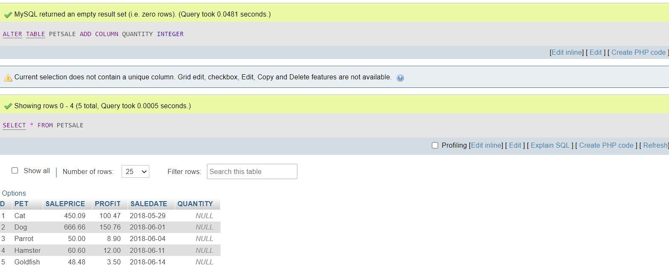
Now update the newly added QUANTITY column of the PETSALE table with some values and show all the table records. Copy the code below and paste it into text area of the SQL page. Click Go.
- UPDATE PETSALE SET QUANTITY = 9 WHERE ID = 1;
- UPDATE PETSALE SET QUANTITY = 3 WHERE ID = 2;
- UPDATE PETSALE SET QUANTITY = 2 WHERE ID = 3;
- UPDATE PETSALE SET QUANTITY = 6 WHERE ID = 4;
- UPDATE PETSALE SET QUANTITY = 24 WHERE ID = 5;

- SELECT * FROM PETSALE;
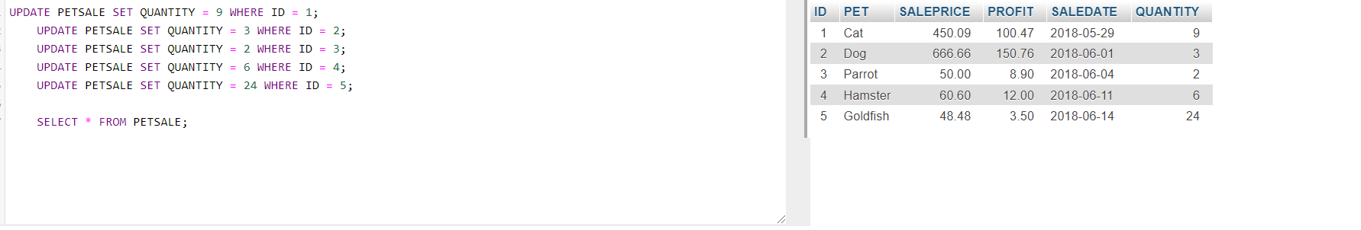

2. Deleting a column
Delete the PROFIT column from the PETSALE table and show the altered table. Copy the code below and paste it into the text area of the SQL page. Click Go.
- 1
- ALTER TABLE PETSALE
- DROP COLUMN PROFIT;

- SELECT * FROM PETSALE;
Copied!
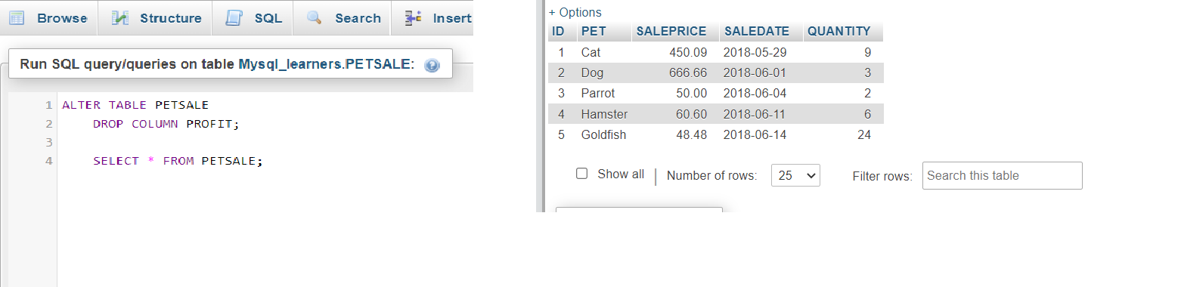

3. Modify a column
Change the data type to VARCHAR(20) type of the column PET of the table PETSALE and show the altered table. Copy the code below and paste it into the text area of the SQL page. Click Go.
- ALTER TABLE PETSALE
- MODIFY PET VARCHAR(20);
- SELECT * FROM PETSALE;
You can click on the table name PETSALE in the tree structure on the left and then click on the Structure tab in the interface. You can then see the table structure shows the modified column data type, as shown in the image below.
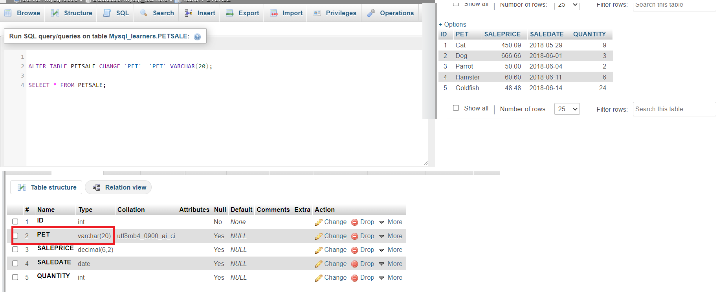

4. Rename a Column
Rename the column PET to ANIMAL of the PETSALE table and show the altered table. Copy the code below and paste it into the text area of the SQL page. Click Go.
- ALTER TABLE `PETSALE` CHANGE `PET` `ANIMAL` varchar(20);

- SELECT * FROM PETSALE;
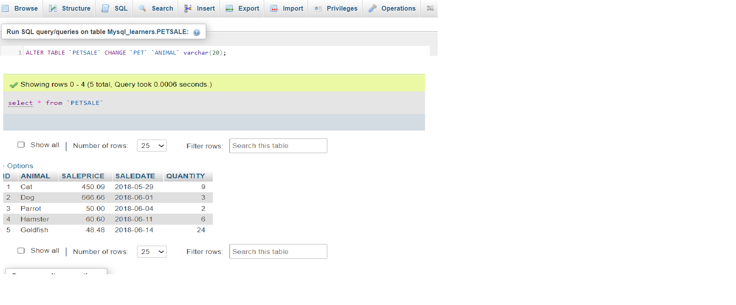

Task 4: TRUNCATE statement
In this exercise, you will use the TRUNCATE statement to remove all rows from an existing table without deleting it.
Let's remove all rows from the PET table and show the empty table. Copy the code below and paste it into the text area of the SQL page. Click Go.
- TRUNCATE TABLE PET ;

- SELECT * FROM PET;
Copied!

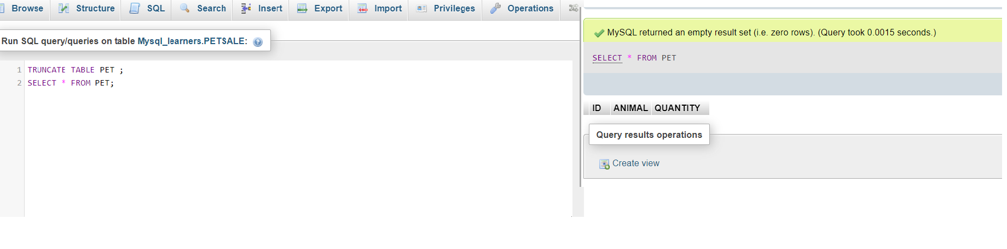
Task 5: DROP statement
Finally, you will use the DROP statement to delete an existing table. Let's delete the PET table and verify if the table still exists or not (the SELECT statement should give an error if a table doesn't exist). Copy the code below and paste it into the text area of the SQL page. Click Go.
- DROP TABLE PET;

- SELECT * FROM PET;
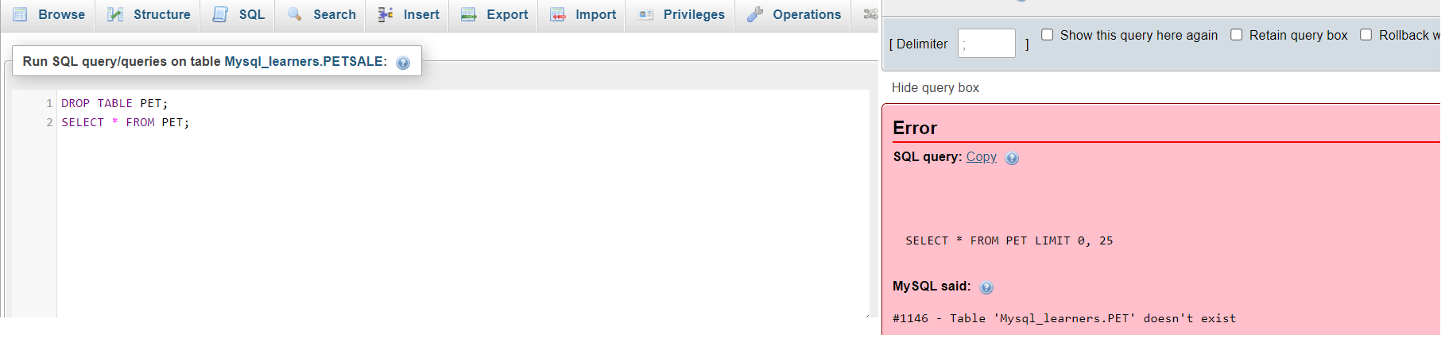

Practice problems
Try the following problems for an enhanced practice of the concepts learned in this lab.
- Create a new table in the database named Toys with attributes as ID (integer), Variety (variable length string), and Quantity (integer). Make sure the ID is not Null.
- CREATE TABLE Toys (
- ID INTEGER NOT NULL,
- Variety VARCHAR(20),
- Quantity INTEGER
- );
- Add the below-mentioned entries to the table using the INSERT statement.
ID | Variety | Quantity
1 | Chew toy | 20
2 | Balls | 50
3 | Bowls | 30
4 | Foldable bed | 40
- ALTER the length of 'Variety' in the table to 30 characters.

- TRUNCATE the table 'Toys'

- DROP the table 'Toys'

